A

Project Report

On

“APPOINTMENT+.COM”

Submitted to

CHHATTISGARH SWAMI VIVEKANAND TECHNICAL UNIVERSITY,

BHILAI

In partial fulfillment of requirement for the award of degree

Of

Bachelor of Engineering

In

Information Technology

By
Anima Sharma
&
Jasmeet Kaur

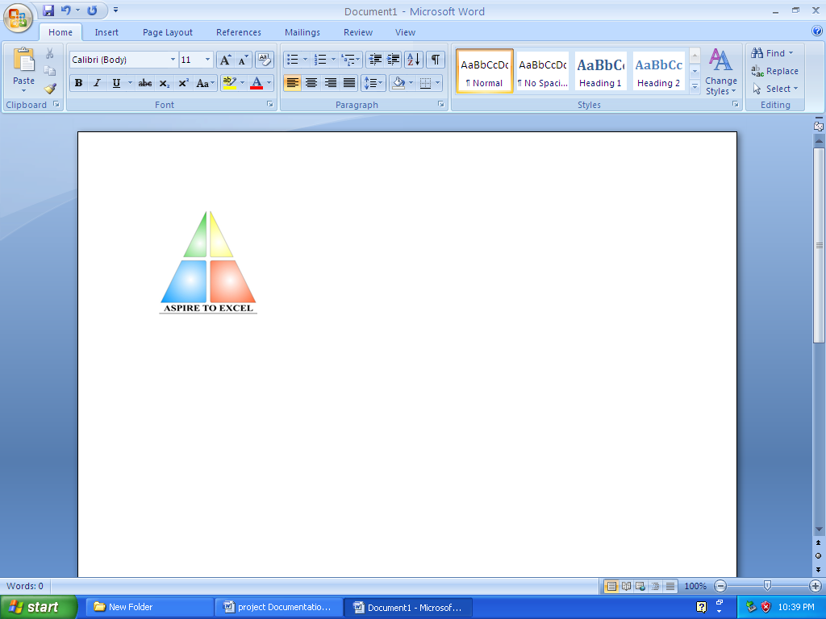

Department of Information Technology,Bhilai Institute of Technology, Bhilai House, Durg, Chattisgarh -491001.

Session: 2006-2010

CERTIFICATE

This is to certify that the report of the project submitted is an outcome of the project work entitled “APPOINTMENT+.COM” carried out by
SNO | NAME OF STUDENT | ROLL NO | ENROLLMENT NO
1. | ANIMA SHARMA | 3013306007 | AA9810
2. | JASMEET KAUR | 3013306016 | AA9839

Carried out under my guidance and supervision for the award of Degree in Bachelor Of Engineering in Information Technology of Chhattisgarh Swami Vivekanand University , Bhilai (C.G) , India .

To the best of my knowledge the report
- Embodies the work of the candidate him/herself ,
- has duly been completed,
- Fulfils the requirement of the Ordinance relating to the B.E. degree of the University and
- Is up to the desired standard for the purpose of which is submitted.

____________________
(Signature of the Guide) Name of Guide : Rajkumar Singh Designation : Lecturer Department : I.T. Institute : B.I.T., DURG
The project work as mentioned above is hereby being recommended and forwarded for examination and evaluation.
(Signature of HOD with seal ) _______________________________

CERTIFICATE BY THE EXAMINERS

This is to certify that the project work entitled

“APPOINTMENT+.COM”

Submitted by
SNO | NAME OF STUDENT | ROLL NO | ENROLLMENT NO
1. | ANIMA SHARMA | 3013306007 | AA9810
2. | JASMEET KAUR | 3013306016 | AA9839

has been examined by the undersigned as a part of the examination for the award of Bachelors of Engineering degree in Information Technology of Chhattisgarh Swami Vivekanand University , Bhilai (C.G) .

___________________ ___________________
Internal Examiner External Examiner
Date: Date:

ACKNOWLEDGEMENT

Working on this project has been a great learning experience for us. There were moments of anxiety, when we could not solve a problem for several days and there were moments when we could solve a problem after struggling for several days. But we have enjoyed every bit of the process and are thankful to all people associated with us during this period.

We convey our sincere thanks to our project guide Mr.Rajkumar Singh, for providing us all sorts of facility. His support and guidance helped us to carry out the project. I owe a great debt of his gratitude for his constant advice, support, co-operation and encouragement throughout the project.

We would like to express our deep gratitude to respected H.O.D Information Technology Department Mrs. Arpana Rawal madam for her helpful solutions and comments enriched by experience, which improved our ideas for betterment of project.

It will be our pleasure to acknowledge, utmost co-operation and valuable suggestion from time to time given by Mr. Vikas Pandey (Project In-Charge and also we would like to thank all those persons who have directly or indirectly helped us by providing books and computer peripherals, and other necessary amenities which helped in the. development of this project which would otherwise have not been possible.

_______ ________ ________
(Roshni Saraogi) (Jitin Bhatia) (Ashish Kr. Ray)

Information Technology, 7th Semester
Bhilai Institute of Technology, Bhilai House, Durg, Chattlsgarh-491001

TABLE OF CONTENTS

- Introduction
- Literature Review
- Problem Identification
  - Current System
  - Solution Strategy
  - Feasibility Study
  - Programming Team Structure
- Methodology
  - Hardware Requirements
  - Software Requirements
  - Technology Used
  - Life Cycle Model
  - Work Flow Diagram
  - Database Design
  - Testing
- Coding
- Snapshots
- Conclusion & scope of further work
- Bibliography

INTRODUCTION

INTRODUCTION

Generally, records that are maintained in the Bhilai Niwas Hotel involve paper work. Every information, whether of customer's significance or not, is maintained as a hard copy by means of registers and log books. It involves a lot of inconvenience in record maintenance and retrieval of information on requirement or demand. So the system needs to be automated.

The automated CIS will facilitate easy record keeping and retrieval and would ease the coordination and maintenance of operation easier. It can also be used to handle the catering section of Bhilai Niwas.

The software provides following functionalities:

- Security- Person Only (either receptionist or the administrator) with valid ID and password shall gain access to the software and its operations.

- Report Generation-The software generates reports that highlight final bill for a customer, Room status for a period or revenue for a period.

- Inter-modular Coordination- The software provides higher degree of coordination among different modules involved in the operation.

- Instant Information- Information regarding rooms and venues is available at any instant for the person concerned.
.

LITERATURE

REVIEW

LITERATURE REVIEW

We got the idea of development of CIS of BHILAI NIWAS from the HOD, IT, BIT, Durg. She suggested the automation of the CIS that would work to the benefit of the Bhilai Niwas and the system as a whole.

1. Immediate assessment and reports of the information generated periodically.

2. The salient feature of this technology is that central database keeps records and different modules access data from it.

3. The customers at Bhilai Niwas need not wait for long to get their bill.

4. The application can also be used to handle the catering services provided to the customers by the hotel.

5. Necessary security features have been introduced to make the CIS infallible from malpractice, using intelligent software or URL copying.

6. The CIS is user-friendly, as the OPERATOR only needs to use simple devices like mouse/keyboard for choosing the menu fields.

Since the project is totally web-based which will run on local servers, therefore the process will also be similar as designing of dynamic websites.

The web design process is briefly explained by the documentation available as :

Web Design Process

Designing a web site is a process consisting of six phases:
.:. Project Definition
.:. Visual Design
.:. Site Development
.:. Testing
.:. Launch
.:. Maintenance

- Project Definition
The most critical step in the web design process is creating an accurate project definition. A project definition includes a project brief and a project plan. The client survey is used to gather the information needed to develop the project brief and plan.

How do you create the project definition?

Step 1: Conduct a Client Survey Interview - The purpose of this interview is to determine the purpose of the project, the target audience, branding/perception goals, content source, technical specs and communication strategy. Use this client survey to guide your interview.

Step 2: Write the Project Brief/Creative Brief - Based on the information gathered in the client survey, write the project brief to define in black and white the project goals, audience profile, audience perception, primary message and competitive advantage. Here is a sample project brief.

Step 3: Write the Project Technical Specifications -Using the information gathered in the client survey along with the technical standards of your organization, document the Technical Specifications to clearly establish requirements like screen resolution, browser compatibility, download time, web standards and accessibility. Here is a sample technical specification.

Step 4: Develop the Project Plan Timeline - Establish the timeline for deliverables and tasks for each phase of the project. Assign due dates and resources.

Step 5: Document Maintenance Considerations -Develop a web site maintenance plan that documents how the site will be updated and reviewed regularly.

- Visual Design
"Structuring the site on paper before starting visual design is a critical step toward effective presentation of content toy our intended audience."

"Designers are not mind readers or magicians. Good design is dependent on good site structure and a solid project definition."

The designer(s) should also review any branding guidelines as well as the technical requirements for screen resolution, browser compatibility, download time, web standards and accessibility.
At this point, the designer(s) has a clear idea of the purpose of the site, the content that will comprise the site, the site architecture and the elements that need to be on each page.

Drawing on their knowledge of design principles (balance, rhythm, proportion, and dominance), design elements (point, line, shape, color, typography) and user centered design (usability); they can develop design options that meet the project goals.

A sample of the visual design tasks:
- 1st draft of visual designs for home page and one sub-page.
- Client provides feedback on designs.
- 2nd draft of visual designs for home page and one sub-page.
- Client selects design and provides feedback.
- 3rd draft of visual design for home page and all unique sub-pages.
- Client provides feedback on design.
- Final visual designs for home page and all unique sub-pages Client approval of final design.

- Site Development
Now it is time to actually build the site. There are two major steps during this stage:
---Technical/Functional Plan
---Build and Integrate the Site

- Technical/Functional Plan-
Start by reviewing the Project Brief, Site Structure and Visual Design and confirm that everything is in alignment and supports the overall project goals and needs. Next, set the technical/functional specifications for the site:

Target Technical Specs - what browsers, as, resolution and connection speeds will you target.

Browsers* - what browsers will you target?
Operating System* -MAC, Windows, Others?
Display Resolution* -what is the screen resolution the site will be designed for? What other screen resolutions will be supported gracefully?
Connection Speed* - what is expected connection speed for your primary users, what other connection speeds will you target?

Functional Specs - what functionality does your site require? Use of W3C web standards is recommended to insure that your site pursues the goals of web for everyone and web on everything.

Project Plan - review your original timeline and the technical and functional specs you've just established. Do you have the resources you need to complete the project on time and within budget? Refine and add details to the project plan you drafted during the Project Definition Stage. Your project plan should now include a detailed list of concrete tasks, assignments, target dates and dependencies between tasks.

- Build and Integrate the Site
To turn all this planning into reality! The steps include:

Build templates using web standards:

- CSS -separate presentation from content
- (X)HTML-use valid (X)HTML
- JavaScript-add scripting, make sure to maintain accessibility
- Optimize -optimize images, CSS and (x) html
- Run initial tests on templates

Create Pages:
- Pour content into templates.
- Establish method for content contributors to review, update and add content.

Backend Development:
Code dynamic features of the site that require database/ CGI and integration like:
- Search
- Personalization/login
- Secure transactions
- Web analytics

- Testing
Your original project plan should always allocate time for formal testing. Ideally, you should identify a person to serve as the Quality Assurance Lead. This individual's priority will be to create a realistic QA plan, manage the testing process, prioritize issues, insure that high priority issues are solved and conduct the final review and release of the project.

Quality Assurance Testing
- Content - accurate, understandable, spelling, grammar (review conducted by content contributors / content editors).
- Links - review site for broken links Functionality -does the site perform the functions defined in the original project definition, create task list and conduct methodical testing.
- Validity -validate (X)HTML, validate CSS.
- Browser/OS/Resolution - test site on the target browsers your defined earlier either manually or using browser cam.
- Connection Speed - use the Web Page Analyzer to get analysis and recommendations on the speed/size of your pages.
- Usability-conduct informal or formal usability testing with your target audience.
- Load Testing - contact your server administrator to discuss load testing techniques.
- Security-request automated Security Scan, review file authorizations, etc.

Prioritize Issues
Taking the time to conduct testing prior to production is an important element in launching a high quality site. However, if you wait until the site is perfect, you will never launch.

There is a balance between perfection and realistic quality that must be struck. As you monitor the list of issues that are uncovered during the testing phase, prioritizing them in at least three categories:

Priority 1 - critical, must be fixed before launch.
Priority 2 - would enhance the site, but we can go live without it, address as soon as time permits.
Priority 3 -future enhancement, nice idea/feature, will consider for future release.

- Launch
As the site gets ready to go production, it is important to document the style guide. A style guide consists of the following elements:
- Visual Design Standards- logos, colors, typography(to keep the site on brand).
- Naming Conventions- for files, directories, CSS, images, titles.
- Site Structure- document the site diagram and indicate how the structure is built to handle growth.
- Templates- provide the (X) HTML templates and CSS indicating layout, typography, size, color, navigation, menus.

If possible, consider a soft launch (a quiet beta launch that allows you to confirm everything is up and running before the official launch date).

- Maintenance
Implement the maintenance plan that was developed in the first stage of this process. Emphasize the importance of keeping a project:
- Complete
- Current
- Coherent
- Accessible
- Attractive
- Robust
- Secure
- Cost Effective
- Aligned with the spirit and goals of the project

PROBLEM IDENTIFICATION

PROBLEM IDENTIFICATION

3.1 CURRENT SYSTEM:
The working of the catering system at any hotel or a restaurant does appear to be quiet simple at first sight. But it is a far more cumbersome. A large number of orders are to be handled at the same time. The project also introduces the concept of ‘Twin Sharing’ in order to accommodate the guests in the same room, coupon system and contract-based catering services.
3.2 PROJECT SOLUTION STRATEGY:
The project takes into consideration various aspects of record maintenance related to customers and employees. It works on different levels, like automating the functioning of employees at reception, administrative monitoring etc. The receptionists have to deal with various tasks such as room booking, availability of rooms, tariffs. Similarly, the higher level management would avail facility to keep track of working. In order to handle the extra requirements of the guests, we are using the ‘Coupon System’ and ‘Contract-based Catering Services’. The project also introduces the concept of ‘Twin Sharing’ in order to accommodate the guests in the same room and generating separate bills.
Additional mechanism of security makes the project better. Every person involved needs to be authenticated if he wishes to use the system. At the same time, he cannot do anything unethically and is in coordination with colleagues. Every transaction done using this system is authenticated and maintenance is far easier. It is easy to get acquainted with.

Beneficiaries of the project:

- Employees at the reception of concerned hotel
- Administrator or In-charge concerned
- BSP Employees accessing intranet facility

3.3 FEASIBILITY STUDY
It is very important to do preliminary investigations regarding the development of the system to ensure its possible usefulness for the organizations.
Thus before developing a system, it is necessary to test the feasibility of the project.

There are five aspects to be covered for testing project feasibility:

Technical Feasibility: The development of a system is technically feasible as the various technological needs for the development & deployment are fulfilled. The system is to be developed using familiar software & hardware tools (PC, Hard Disk, Java 1.6, and Web browser).

Operational Feasibility: This feasibility depends much on the willingness of the users to accept the system replacing their manual or old systems. As the users propose this system, its operation is much feasible .The only thing is that the users of the proposed system should be trained for using the system. The willingness to learn the new system developed makes the system much more feasible.

Implementation Feasibility: The organization has all the facilities required for developing the system. All software's required for the developments of the system are provided by the organizations & has got the necessary infrastructure, which makes the project feasible in implementing.

Schedule Feasibility: University allocates the time of weeks for the project, which seems to be enough for the development of the system as per the requirements put forward by the organizations. So, we can say that the project is feasible in terms of schedule.

Economic Feasibility: Since all the above mentioned feasibility tests are passed for the carrying out of the project. The feasibility was not the problem for such a large organization.

3.4 PROGRAMMING TEAM STRUCTURE:

In our project, we have employed the democratic programming team structure. Our team has no permanent leader; rather, "task coordinators are appointed for short duration & replaced by others". All the team members have possess equal expertise thereby making the decision making process is collective. Our team consists of three persons with efficiency in PHP, in which our project has been developed.
In our project team, no pattern of hierarchy has been followed. Every team member is free to communicate his views/opinions directly to any member, he wishes.

JITIN BHATIA

ASHISH Kr. RAY
ROSHNI SARAOGI

Democratic Team Structure

METHODOLOGY

METHODOLOGY

4.1 HARDWARE REQUIREMENTS

The hardware requirements of our project are as follows:

Processor - Pentium 3 or above
Mother Board -Intel 810 or above
VDU Resolution -SVGA supporting at least 800X 600
RAM -256 MB or above
Hard Disk -10GBor above
Monitor -Monochrome or colored
Printer -Laser or any other
Keyboard & Mouse -Any compatible with above configuration

4.2 SOFTWARE REQUIREMENTS

Here are the software requirements of our project:

OPERATING SYSTEM - (Server side) -Linux
- (Client side) - Windows/Linux
WEB BROWSER -Mozilla Firefox/Internet Explorer

4.3 TECHNOLOGY USED

(Technological Requirements for project development)

Front end using PHP:-
PHP is an HTML-embedded scripting language. Much of its syntax is borrowed from C, Java and Perl with a couple of unique PHP-specific features thrown in.
The goal of the language is to allow web developers to write dynamically generated pages quickly. "
This is generally a good definition of PHP. However, it does contain a lot of terms we may not be used to. Another way to think of PHP is a powerful, behind the scenes scripting language that your visitors won't see.

When someone visits your PHP webpage, our web server processes the PHP code. It then sees which parts it needs to show to visitors (content and pictures) and hides the other stuff (file operations, math calculations, etc.) then translates our PHP into HTML. After the translation into HTML, it sends the webpage to our visitor's web browser.

PHP allows us to:
- Reduce the time to create large websites.
- Create a customized user experience for visitors based on information that you have gathered from them.
- Open up thousands of possibilities for online tools.
- Allow creation of shopping carts for e-commerce websites.

MYSQL
A database is a structure that comes in two flavors: a flat database and a relational database. A relational database is much more oriented to the human mind and is often preferred over the gabble-de-gook flat databases that are just stored on hard drives like a text file. MYSQL is a relational database.

In a relational structured database there are tables that store data. The columns define which kinds of information will be stored in the table. An individual column must be created for each type of data you wish to store.

Databases are most useful when it comes to storing information that fits into logical categories. For example, say that you wanted to store information of all the employees in a company. With a database you can group different parts of your business into separate tables to help store your information logically. Example tables might be: Employees, Supervisors, and Customers. Each table would then contain columns specific to these three areas.

MYSQL is currently the most popular open source database server in existence. On top of that, it is very commonly used in conjunction with PHP scripts to create powerful and dynamic server-side applications.

TOOLS USED

Web Browsers

A web browser is the program we use to view pages on and navigate the World Wide Web. Web browsers are sometimes refer to as web clients or other fancy names ("Internet Navigation Tools"), but web browser is most common terms.

A wide array of web browser is available for just about every platform you can imagine, including graphical user interface based system (MAC, Windows) and text only for dialup UNIX connections.
- Microsoft Internet Explorer
- Mozilla Firefox

XAMPP Server

To view and brows pages on the web, all we need is a web browser. To publish pages on the Web, most of the time we will need a web server. A web server is a program that runs on the website and is responsible for replying to web browser request for a file. You need web server to publish pages on the web.

It is a complete package that includes front end programming language (PHP), MYSQL DB, Apache server and windows operating system.

The Apache HTTP Server, commonly referred to simply as Apache is a web server notable for playing a key role in the initial growth of the World Wide Web. Apache was the first viable alternative to the Netscape Communications Corporation web server (currently known as Sun Java System Web Server), and has since evolved to rival other Unix-based web servers in terms of functionality and performance. The majority of all web servers using Apache are Linux web servers.

4.4 LIFE CYCLE MODEL

Incremental Model

We have adopted the "Incremenal Model" to develop our project as the requirements are not fixed and can be added at later point of time. We have been provided with certain insights into the way of operating with our client that we have to take into consideration in developing the final product for them.

Different Phases of Incremental Model

Various phases of Incremental Model which we have followed in our project are:

- Analysis Phase
- Design Phase
- Code Phase
- Test Phase
Here we will describe all the four phases of incremental model that how we have proceed in our project.

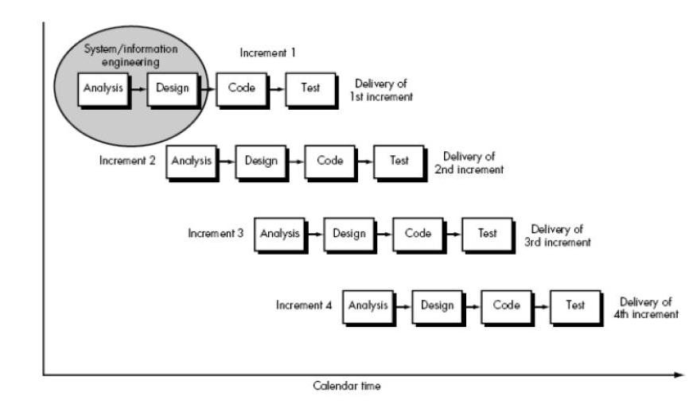

Analysis Phase

In analysis phase we made a detailed research about working of various Hotel Management Software's. We tried to develop various logics for developing an easier method for development. We also referred to various concepts of PHP related to implementation to make a feasible study.

Design Phase
After complete analysis of our project we were in the position to think of different functions, database and modules which will be required in our project. At the end of this phase we had a clear picture in our mind that how user interface will look and how data will flow within different modules.

Code Phase

In this phase we had a clear idea about the design of our project so we had started making code in PHP. While coding we discovered various logical and syntactical errors. Our aim in this phase was to make clean and efficient code.

Test Phase

This phase involves execution of different modules. We tested all our modules to check and test their overall performance due to integration. After discovering few faults, we improved our code and tested it again till our requirements were satisfied.

4.5 ARCHITECTURAL DESIGN

The Architectural design of a software project involves:

- Identifying the software components.
- Decoupling & decomposing the software components into modules & conceptual data structures.
- Specifying the interconnections between the various components.

4.6 DATABASE DESIGN

PROJECT DEVELOPMENT: included as a Technical Functional Plan. This phase was concerned with what browsers, OS, resolution and connections are targeted and what functionality does the project require? Review of original timeline and the technical and functional specs established were done. Finally it was time to turn all this planning into reality by building and integrating the project by coding for it .Time allocated for this phase was around four to five weeks.

DATA FLOW DIAGRAM
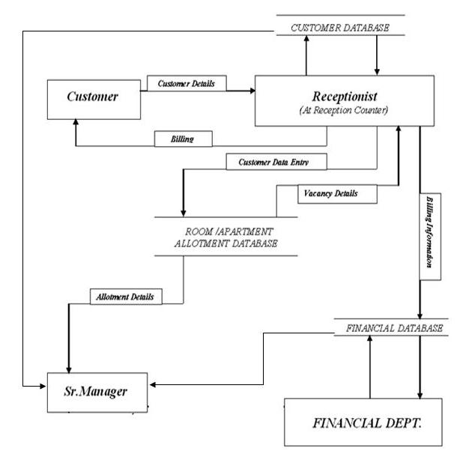

4.7 TESTING

Software Test Environment
Software Version: The system describes web server version XAMPP 1.7.2.
Languages/Compilers: All software described is written in PHP. It is an integrated web server of PHP, MYSQL and Linux Apache server.

Third Party Software: All Web software is run by Apache Web servers. All Web Services use XAMPP 1.7.2. We use Apache server (http://ant.apache.org/) for both source compilation and for runtime execution management. These software packages are in turn built on several other projects; a complete list is available from the provided URLs. All third party software is freely available at no cost and open source.

General Information
Component testing is used to ensure each of the individual components of the system (i.e. database access or application execution) operates correctly.

Tests are grouped into the following general categories:

- Positive User Testing: The system, when used correctly in the manner prescribed in the user manual, must generate the correct final results for the selected application.
- Negative User Testing: The system should be tested for invalid user inputs and actions.
- System Testing: The product should be tested for cases when partial system failures occur; i.e. one of the hosts or Web services is temporarily unavailable.

This phase started as the site was developed. The testing is performed based on various test cases and system has been deployed. After testing, we finally hosted this web based project on local server/web server.

CODING

<?php

session_start();
include('datetimeconvertor.php');
if (!(isset($_SESSION['login']) && $_SESSION['login'] != '' && $_SESSION['category']=='Manager')) {
header ("Location: login.php");
} ?>
<!DOCTYPE html PUBLIC "-//W3C//DTD XHTML 1.0 Strict//EN" "http://www.w3.org/TR/xhtml1/DTD/xhtml1-strict.dtd">

<html xmlns="http://www.w3.org/1999/xhtml">
<head>
<meta http-equiv="content-type" content="text/html; charset=utf-8" />
<title>Bhilai Niwas Hotel</title>
<meta name="keywords" content="" />
<meta name="description" content="" />
<link href="default.css" rel="stylesheet" type="text/css" />
<!--[if lt IE 7.]>
<script defer type="text/javascript" src="pngfix.js"></script>
<![endif]-->
<script language="javascript" type="text/javascript" src="datetimepicker.js">
</script>
<script language="javascript" type="text/javascript">
function cancel()
{
location.href="managerZone.php";
}
</script>
<script type="text/javascript">

function formValidator(){

var bsdate = document.getElementById('bsdate');

if(isEmpty(bsdate, "Please enter date")){
return true;
}
return false;
}

function isEmpty(elem, helperMsg){
if(elem.value.length == 0){
alert(helperMsg);
elem.focus(); // set the focus to this input
return false;
}
return true;
}
</script>
<script language="JavaScript1.2" src="ajlib.js"></script>
<script language="JavaScript1.2" src="ajscroller.js"></script>
<script type="text/javascript">
function intimate()
{
var msg="<?php echo($_SESSION['intimation']);?>";
// alert(msg.length);
if(msg.length>0)
{
alert(msg);
}
LoadAJScroller();
}

</script>
</head>
<body onLoad="intimate()" onResize="LoadAJScroller()">
<div id="outer">
<div id="header"><table cellspacing="0" cellpadding="0" align="left" border="0">

<tr>
<td align="middle"><br>
<center><img hspace="0" src="images/logo.png"
border=0 ></center>
</td></tr>
<tr><td align="middle">
<center><font face="Verdana" color="#ffffff" size="2"><strong>SAIL<br>Bhilai Steel

Plant</strong></center></font></td></tr></table>
<table cellspacing="0" cellpadding="3" width="80%" align="left" border="0" >

<tr>
<td>
<p align="center"></p>
<p align="center"><font color="#ffffff"><strong><font face="Times New Roman"
size=5> </font></strong></font>&nbsp;</p>
<p align="center"><font color="#ffffff"><strong><font face="Times New Roman"
size=5>CENTRALIZED INFORMATION SYSTEM </font></strong></font></p>
<p align="center">&nbsp;</p>
<p align="center"></p>
<p align="center"><font face="Times New Roman" color="#ffffff"
size=5><strong>BHILAI&nbsp;NIWAS</strong></font></p>
<p align="center"><strong><font face="Times New Roman"
color=#ffffff size=5></font></strong>&nbsp;</p></td></tr></table>
<p>&nbsp;</p>
<p>&nbsp;</p>
<p>&nbsp;</p>
<p>&nbsp;</p>
<p>&nbsp;</p>
<p>&nbsp;</p>
<p>&nbsp;</p>
<p>
<table cellspacing="0" cellpadding="13" width="50" align="right" border="0" style="WIDTH: 106px; HEIGHT: 19px">

<tr>
<td><a href="MANAGER ZONE.pdf" target='x' onclick="window.open('', 'x', 'width=600, height=600, scrollbars=yes')"><font color="#ffffff"><strong>HELP</strong></font></a></td>
<td><a href=logout.php><font color="#ffffff"><strong>Logout</strong></font></a></td>

</tr>
</table></p>
</div>
<div id="content">
<div id="tertiaryContent">
<h3><center>Room/Apartment Status Summary</center></h3>
<?php
include('removewastebooking.php');
removewastebooking();

mysql_connect("localhost", "root", "");
mysql_select_db("mis_bhilainiwas");
/*Vacant/Ready Room(s)*/
$qrvr="select * from room_details where room_status='Vacant/Ready'";
$rrvr=mysql_query($qrvr);
$nvrr=mysql_num_rows($rrvr);
echo "<font size=2>Vacant Room(s) = $nvrr</font>";
echo "<br>";
if($nvrr!=0)
{
echo "<form method='post' action='roomApartStatus.php' target='rastatus' onsubmit=\"window.open('', 'rastatus', 'width=400, height=400, scrollbars=yes')\">";
echo "<input type='hidden' name='head' value='VACANT ROOM(S)'>";
echo "<input type='hidden' name='tname' value='room_details'>";
echo "<input type='hidden' name='fname' value='room_status'>";
echo "<input type='hidden' name='fvalue' value='Vacant/Ready'>";
echo "<p align=right><input type='submit' name='rastatus' value='Details..'>";
echo "</form>";
}
echo "<hr><br>";

/*Occupied Room(s)*/
$qro="select * from room_details where room_status='Occupied'";
$rro=mysql_query($qro);
$nor=mysql_num_rows($rro);
echo "Occupied Room(s) = $nor";
echo "<br>";
if($nor!=0)
{
echo "<form method='post' action='roomApartStatus.php' target='rastatus' onsubmit=\"window.open('', 'rastatus', 'width=400, height=400, scrollbars=yes')\">";
echo "<input type='hidden' name='head' value='OCCUPIED ROOM(S)'>";
echo "<input type='hidden' name='tname' value='room_details'>";
echo "<input type='hidden' name='fname' value='room_status'>";
echo "<input type='hidden' name='fvalue' value='Occupied'>";
echo "<p align=right><input type='submit' name='rastatus' value='Details..'>";
echo "</form>";
}
echo "<hr><br>";

/*Room(s) Vacant but not Ready*/
$qrvnr="select * from room_details where room_status='Vacant/Not Ready'";
$rrvnr=mysql_query($qrvnr);
$nrvnr=mysql_num_rows($rrvnr);
echo "Room(s) Vacant/Not Ready = $nrvnr";
echo "<br>";
if($nrvnr!=0)
{
echo "<form method='post' action='roomApartStatus.php' target='rastatus' onsubmit=\"window.open('', 'rastatus', 'width=400, height=400, scrollbars=yes')\">";
echo "<input type='hidden' name='head' value='ROOM(S) VACANT BUT NOT READY'>";
echo "<input type='hidden' name='tname' value='room_details'>";
echo "<input type='hidden' name='fname' value='room_status'>";
echo "<input type='hidden' name='fvalue' value='Vacant/Not Ready'>";
echo "<p align=right><input type='submit' name='rastatus' value='Details..'>";
echo "</form>";
}
echo "<hr><br>";

/*Room(s) Under Maintenance*/
$qrum="select * from room_details where room_status='Under Maintenance'";
$rrum=mysql_query($qrum);
$nrum=mysql_num_rows($rrum);
echo "Room(s) Under Maintenance = $nrum";
echo "<br>";
if($nrum!=0)
{
echo "<form method='post' action='roomApartStatus.php' target='rastatus' onsubmit=\"window.open('', 'rastatus', 'width=400, height=400, scrollbars=yes')\">";
echo "<input type='hidden' name='head' value='ROOM(S) UNDER MAINTENANCE'>";
echo "<input type='hidden' name='tname' value='room_details'>";
echo "<input type='hidden' name='fname' value='room_status'>";
echo "<input type='hidden' name='fvalue' value='Under Maintenance'>";
echo "<p align=right><input type='submit' name='rastatus' value='Details..'>";
echo "</form>";
}
echo "<hr><br>";

/*Room(s) available on date*/
echo "Room(s) Available on Date :";
echo "<br>";
echo "<form method='post' action='adroomApartStatus.php' target='rastatus' onsubmit=\"window.open('', 'rastatus', 'width=400, height=400, scrollbars=yes')\">";
?>
<input name=givenrdate readonly=readonly id=givenrdate width="0"><a href="javascript:NewCal('givenrdate','ddmmyyyy')"><img src="images/cal.gif" width="16" height="16" border="0" alt="Pick a date"></a>
<?php
echo "<input type='hidden' name='head' value='VACANT ROOM(S)'>";
echo "<input type='hidden' name='tname' value='room_details'>";
echo "<input type='hidden' name='fname' value='room_status'>";
echo "<input type='hidden' name='fvalue' value='Vacant/Ready'>";
echo "<p align=right><input type='submit' name='rastatus' value='Details..'>";
echo "</form>";

echo "<hr><br>";
/*Vacant/Ready Apartment(s)*/
$qavr="select * from apart_details where apart_status='Vacant/Ready'";
$ravr=mysql_query($qavr);
$nvra=mysql_num_rows($ravr);
echo "Vacant Apt(s) = $nvra";
echo "<br>";
if($nvra!=0)
{
echo "<form method='post' action='roomApartStatus.php' target='rastatus' onsubmit=\"window.open('', 'rastatus', 'width=400, height=400, scrollbars=yes')\">";
echo "<input type='hidden' name='head' value='VACANT APARTMENT(S)'>";
echo "<input type='hidden' name='tname' value='apart_details'>";
echo "<input type='hidden' name='fname' value='apart_status'>";
echo "<input type='hidden' name='fvalue' value='Vacant/Ready'>";
echo "<p align=right><input type='submit' name='rastatus' value='Details..'>";
echo "</form>";
}
echo "<hr><br>";

/*Occupied Apartment(s)*/
$qao="select * from apart_details where apart_status='Occupied'";
$rao=mysql_query($qao);
$noa=mysql_num_rows($rao);
echo "Occupied Apt(s) = $noa";
echo "<br>";
if($noa!=0)
{
echo "<form method='post' action='roomApartStatus.php' target='rastatus' onsubmit=\"window.open('', 'rastatus', 'width=400, height=400, scrollbars=yes')\">";
echo "<input type='hidden' name='head' value='OCCUPIED APARTMENT(S)'>";
echo "<input type='hidden' name='tname' value='apart_details'>";
echo "<input type='hidden' name='fname' value='apart_status'>";
echo "<input type='hidden' name='fvalue' value='Occupied'>";
echo "<p align=right><input type='submit' name='rastatus' value='Details..'>";
echo "</form>";
}
echo "<hr><br>";

/*Apt(s) Vacant but not Ready*/
$qavnr="select * from apart_details where apart_status='Vacant/Not Ready'";
$ravnr=mysql_query($qavnr);
$navnr=mysql_num_rows($ravnr);
echo "Apt(s) Vacant/Not Ready = $navnr";
echo "<br>";
if($navnr!=0)
{
echo "<form method='post' action='roomApartStatus.php' target='rastatus' onsubmit=\"window.open('', 'rastatus', 'width=400, height=400, scrollbars=yes')\">";
echo "<input type='hidden' name='head' value='APARTMENT(S) VACANT BUT NOT READY'>";
echo "<input type='hidden' name='tname' value='apart_details'>";
echo "<input type='hidden' name='fname' value='apart_status'>";
echo "<input type='hidden' name='fvalue' value='Vacant/Not Ready'>";
echo "<p align=right><input type='submit' name='rastatus' value='Details..'>";
echo "</form>";
}
echo "<hr><br>";

/*Apt(s) Under Maintenance*/
$qaum="select * from apart_details where apart_status='Under Maintenance'";
$raum=mysql_query($qaum);
$naum=mysql_num_rows($raum);
echo "Apt(s) Under Maintenance = $naum";
echo "<br>";
if($naum!=0)
{
echo "<form method='post' action='roomApartStatus.php' target='rastatus' onsubmit=\"window.open('', 'rastatus', 'width=400, height=400, scrollbars=yes')\">";
echo "<input type='hidden' name='head' value='APARTMENT(S) UNDER MAINTENANCE'>";
echo "<input type='hidden' name='tname' value='apart_details'>";
echo "<input type='hidden' name='fname' value='apart_status'>";
echo "<input type='hidden' name='fvalue' value='Under Maintenance'>";
echo "<p align=right><input type='submit' name='rastatus' value='Details..'>";
echo "</form>";
}
echo "<hr><br>";

/*Apartment(s) available on date*/
echo "Apartment(s) Available on Date :";
echo "<br>";
echo "<form name=aaod method='post' action='adroomApartStatus.php' target='rastatus' onsubmit=\"window.open('', 'rastatus', 'width=400, height=400, scrollbars=yes')\">";
?>
<input name=givenadate readonly=readonly id=givenadate width="0"><a href="javascript:NewCal('givenadate','ddmmyyyy')"><img src="images/cal.gif" width="16" height="16" border="0" alt="Pick a date"></a>
<?php
echo "<input type='hidden' name='head' value='VACANT APARTMENT(S)'>";
echo "<input type='hidden' name='tname' value='apart_details'>";
echo "<input type='hidden' name='fname' value='apart_status'>";
echo "<input type='hidden' name='fvalue' value='Vacant/Ready'>";
echo "<p align=right><input type='submit' name='rastatus' value='Details..'>";
echo "</form>";

echo "<hr><br>";
?>
<p>&nbsp;</p>
</div>
<div id="primaryContentContainer">
<marquee><a href="advancebookingrecord.php" target='x' onclick="window.open('', 'x', 'width=600, height=600, scrollbars=yes')">
<font color="#FF0000" face="Georgia, Times New Roman, Times, serif" size="+1">

<?php
include('giveAdvancebookingStatus.php');
$roomapart=giveRoomApart();
$halls=giveHalls();

echo("Advance Booking for Today:---");
?>
<font color="#0000FF" face="Georgia, Times New Roman, Times, serif" size="+1">

<?php
echo("Rooms : ".$roomapart[0]." | Apartments : ".$roomapart[1]);
if($halls[0]!='nil')
{
$_SESSION['hall']='exist';
echo(" $|$ Halls : ");
foreach($halls as $k=>$v)
{
if($k==0)
{ echo($v);}
else
{ echo(" , ".$v); }

}
}

?>
</font>
<?php echo("---:");?></font></a></marquee>
<div id="primaryContent">
<h2 align="center"><strong>Manager's</strong> Zone</h2>
<p>&nbsp;</p>
<?php

$query="select rem_date,rem_text from reminder";

$rst = mysql_query($query) or die("Error in data Selection. Contact Sr. Manager !!!");
?>
<p>

<table align="center"><tr><td>
<script language="JavaScript1.2">
<!--
aj_scroller = new AJScroller();
aj_scroller.width = 400;
aj_scroller.height = 150;
aj_scroller.scrollspeed = 50;
aj_scroller.pausedelay = 2000;
aj_scroller.pausemouseover = true;
aj_scroller.add('<center><u><font size="2"><b> </b></font></u></center>');
aj_scroller.add('<center><u><font size="2"><b> </b></font></u></center>');
aj_scroller.add('<center><u><font size="2"><b> </b></font></u></center>');
aj_scroller.add('<center><u><font size="2"><b> </b></font></u></center>');
aj_scroller.add('<center><u><font size="2"><b> </b></font></u></center>');
aj_scroller.add('<center><u><font size="2"><b> </b></font></u></center>');
aj_scroller.add('<center><u><font size="2"><b> </b></font></u></center>');
aj_scroller.add('<center><u><font size="2"><b> </b></font></u></center>');
aj_scroller.add('<center><u><font size="2"><b> </b></font></u></center>');

aj_scroller.add('<center><u><font size="2"><b>Welcome to Bhilai Niwas</b></font></u></center>');
aj_scroller.add('<center><font size="2" color="red"><b>This application is helpful for handling all working of a Hotel.</b></font></center>');
aj_scroller.add('<u><font size="4" color="blue"><?php echo date('d-M-Y');?></font><u>');
<?php while($row=mysql_fetch_row($rst)){?>
aj_scroller.add('<font size="3"><?php echo("".dmy($row[0])."-->".$row[1]);?></font>');

<?php }?>
aj_scroller.display();
// -->
</script>
</td></tr></table>
</p>

</div>
</div>
<div id="secondaryContent">
<h3 align="center">
Manager's Menu</h3>
<ul><li type="square"><strong>Report</strong>
<ul>
<li type="disc"><a href="revenueOccupancy.php">Revenue Generation & Occupancy</a></li>
<li type="disc"><a href="billRecords.php">Bill Records</a></li>
</ul></li></ul>
<ul><li type="square"><strong>Search</strong>
<ul>
<li type="disc"><a href="searchBookingStatus.php">Occupancy Status</a></li>
<li type="disc"><a href="adsearchBookingStatus.php">Advance Booking Status</a></li>
</ul></li></ul>

<ul><li type="square"><strong>Administrative</strong>
<ul>
<li type="disc"><a href="changePSW.php">Change own Password</a></li>
<li type="disc"><a href="createuser.php">Create user</a></li>
<li type="disc"><a href="deleteuser.php">Remove user</a></li>
<li type="disc"><a href="receptionZone.php">Enter Reception Zone</a></li>
<li type="disc"><a href="changeTariff.php">Change Tariff(R/A)</a></li>
<li type="disc"><a href="changeHallTariff.php">Change Tariff(Hall)</a></li>
<li type="disc"><a href="reminder.php">Add Reminder</a></li>
<li type="disc"><a href="deleteremider.php">Delete Reminder</a></li>
</ul></li></ul>

<ul><li type="square"><strong>Hall Booking</strong>

<ul>
<li type="disc"><a href="bookHall.php">Advance Booking</a></li>
<li type="disc"><a href="ammendHall.php">Booking Ammendment</a></li>
<li type="disc"><a href="allotHall.php">Allotment</a></li>
<li type="disc"><a href="cancelHall.php">Cancellation</a></li>
<li type="disc"><a href="hallDepart.php">Edit Check Out</a></li>
<li type="disc"><a href="hallbill.php">Bill Generation</a></li>
</ul></li></ul>

<p>&nbsp;</p>
<div class="xbg"></div>
<ul></ul>
<ul></ul>
<ul></ul>
</div>
<div class="clear"></div>
</div>

<div id="footer">
<p></p>

</div>
</div>
</body>
</html>
<?php //session_unregister($_SESSION['intimation']);
$_SESSION['intimation']='';
?>
<?php

session_start();

if (!(isset($_SESSION['login']) && $_SESSION['login'] != '' && $_SESSION['category']=='Manager')) {
header ("Location: login.php");
} ?>
<!DOCTYPE html PUBLIC "-//W3C//DTD XHTML 1.0 Strict//EN" "http://www.w3.org/TR/xhtml1/DTD/xhtml1-strict.dtd">

<html xmlns="http://www.w3.org/1999/xhtml">
<head>
<meta http-equiv="content-type" content="text/html; charset=utf-8" />
<title>Bhilai Niwas Hotel</title>
<meta name="keywords" content="" />
<meta name="description" content="" />
<link href="default.css" rel="stylesheet" type="text/css" />
<!--[if lt IE 7.]>
<script defer type="text/javascript" src="pngfix.js"></script>
<![endif]-->
<script language="javascript" type="text/javascript" src="datetimepicker.js">
</script>
<script language="javascript" type="text/javascript">
function cancel()
{
location.href="managerZone.php";
}
</script>

</head>
<body>
<div id="outer">
<div id="header"><table cellspacing="0" cellpadding="0" align="left" border="0">

<tr>
<td align="middle"><br>
<center><img hspace="0" src="images/logo.png"
border=0 ></center>
</td></tr>
<tr><td align="middle">
<center><font face="Verdana" color="#ffffff" size="2"><strong>SAIL<br>Bhilai Steel

Plant</strong></center></font></td></tr></table>
<table cellspacing="0" cellpadding="3" width="80%" align="left" border="0" >

<tr>
<td>
<p align="center"></p>
<p align="center"><font color="#ffffff"><strong><font face="Times New Roman"
size=5> </font></strong></font>&nbsp;</p>
<p align="center"><font color="#ffffff"><strong><font face="Times New Roman"
size=5>CENTRALIZED INFORMATION SYSTEM </font></strong></font></p>
<p align="center">&nbsp;</p>
<p align="center"></p>
<p align="center"><font face="Times New Roman" color="#ffffff"
size=5><strong>BHILAI&nbsp;NIWAS</strong></font></p>
<p align="center"><strong><font face="Times New Roman"
color=#ffffff size=5></font></strong>&nbsp;</p></td></tr></table>
<p>&nbsp;</p>
<p>&nbsp;</p>
<p>&nbsp;</p>
<p>&nbsp;</p>
<p>&nbsp;</p>
<p>&nbsp;</p>
<p>&nbsp;</p>
<p>
</p>
</div>
<div id="content">
<div id="tertiaryContent">
<h3><center>Room/Apartment Status Summary</center></h3>
<?php
mysql_connect("localhost", "root", "");
mysql_select_db("mis_bhilainiwas");
/*Vacant/Ready Room(s)*/
$qrvr="select * from room_details where room_status='Vacant/Ready'";
$rrvr=mysql_query($qrvr);
$nvrr=mysql_num_rows($rrvr);
echo "<font size=2>Vacant Room(s) = $nvrr</font>";
echo "<br>";
if($nvrr!=0)
{
echo "<form method='post' action='roomApartStatus.php' target='rastatus' onsubmit=\"window.open('', 'rastatus', 'width=400, height=400, scrollbars=yes')\">";
echo "<input type='hidden' name='head' value='VACANT ROOM(S)'>";
echo "<input type='hidden' name='tname' value='room_details'>";
echo "<input type='hidden' name='fname' value='room_status'>";
echo "<input type='hidden' name='fvalue' value='Vacant/Ready'>";
echo "<p align=right><input type='submit' name='rastatus' value='Details..'>";
echo "</form>";
}
echo "<hr><br>";

/*Occupied Room(s)*/
$qro="select * from room_details where room_status='Occupied'";
$rro=mysql_query($qro);
$nor=mysql_num_rows($rro);
echo "Occupied Room(s) = $nor";
echo "<br>";
if($nor!=0)
{
echo "<form method='post' action='roomApartStatus.php' target='rastatus' onsubmit=\"window.open('', 'rastatus', 'width=400, height=400, scrollbars=yes')\">";
echo "<input type='hidden' name='head' value='OCCUPIED ROOM(S)'>";
echo "<input type='hidden' name='tname' value='room_details'>";
echo "<input type='hidden' name='fname' value='room_status'>";
echo "<input type='hidden' name='fvalue' value='Occupied'>";
echo "<p align=right><input type='submit' name='rastatus' value='Details..'>";
echo "</form>";
}
echo "<hr><br>";

/*Room(s) Vacant but not Ready*/
$qrvnr="select * from room_details where room_status='Vacant/Not Ready'";
$rrvnr=mysql_query($qrvnr);
$nrvnr=mysql_num_rows($rrvnr);
echo "Room(s) Vacant/Not Ready = $nrvnr";
echo "<br>";
if($nrvnr!=0)
{
echo "<form method='post' action='roomApartStatus.php' target='rastatus' onsubmit=\"window.open('', 'rastatus', 'width=400, height=400, scrollbars=yes')\">";
echo "<input type='hidden' name='head' value='ROOM(S) VACANT BUT NOT READY'>";
echo "<input type='hidden' name='tname' value='room_details'>";
echo "<input type='hidden' name='fname' value='room_status'>";
echo "<input type='hidden' name='fvalue' value='Vacant/Not Ready'>";
echo "<p align=right><input type='submit' name='rastatus' value='Details..'>";
echo "</form>";
}
echo "<hr><br>";

/*Room(s) Under Maintenance*/
$qrum="select * from room_details where room_status='Under Maintenance'";
$rrum=mysql_query($qrum);
$nrum=mysql_num_rows($rrum);
echo "Room(s) Under Maintenance = $nrum";
echo "<br>";
if($nrum!=0)
{
echo "<form method='post' action='roomApartStatus.php' target='rastatus' onsubmit=\"window.open('', 'rastatus', 'width=400, height=400, scrollbars=yes')\">";
echo "<input type='hidden' name='head' value='ROOM(S) UNDER MAINTENANCE'>";
echo "<input type='hidden' name='tname' value='room_details'>";
echo "<input type='hidden' name='fname' value='room_status'>";
echo "<input type='hidden' name='fvalue' value='Under Maintenance'>";
echo "<p align=right><input type='submit' name='rastatus' value='Details..'>";
echo "</form>";
}
echo "<hr><br>";

/*Room(s) available on date*/
echo "Room(s) Available on Date :";
echo "<br>";
echo "<form method='post' action='adroomApartStatus.php' target='rastatus' onsubmit=\"window.open('', 'rastatus', 'width=400, height=400, scrollbars=yes')\">";
?>
<input name=givenrdate readonly=readonly id=givenrdate width="0"><a href="javascript:NewCal('givenrdate','ddmmyyyy')"><img src="images/cal.gif" width="16" height="16" border="0" alt="Pick a date"></a>
<?php
echo "<input type='hidden' name='head' value='VACANT ROOM(S)'>";
echo "<input type='hidden' name='tname' value='room_details'>";
echo "<input type='hidden' name='fname' value='room_status'>";
echo "<input type='hidden' name='fvalue' value='Vacant/Ready'>";
echo "<p align=right><input type='submit' name='rastatus' value='Details..'>";
echo "</form>";

echo "<hr><br>";

/*Vacant/Ready Apartment(s)*/
$qavr="select * from apart_details where apart_status='Vacant/Ready'";
$ravr=mysql_query($qavr);
$nvra=mysql_num_rows($ravr);
echo "Vacant Apt(s) = $nvra";
echo "<br>";
if($nvra!=0)
{
echo "<form method='post' action='roomApartStatus.php' target='rastatus' onsubmit=\"window.open('', 'rastatus', 'width=400, height=400, scrollbars=yes')\">";
echo "<input type='hidden' name='head' value='VACANT APARTMENT(S)'>";
echo "<input type='hidden' name='tname' value='apart_details'>";
echo "<input type='hidden' name='fname' value='apart_status'>";
echo "<input type='hidden' name='fvalue' value='Vacant/Ready'>";
echo "<p align=right><input type='submit' name='rastatus' value='Details..'>";
echo "</form>";
}
echo "<hr><br>";

/*Occupied Apartment(s)*/
$qao="select * from apart_details where apart_status='Occupied'";
$rao=mysql_query($qao);
$noa=mysql_num_rows($rao);
echo "Occupied Apt(s) = $noa";
echo "<br>";
if($noa!=0)
{
echo "<form method='post' action='roomApartStatus.php' target='rastatus' onsubmit=\"window.open('', 'rastatus', 'width=400, height=400, scrollbars=yes')\">";
echo "<input type='hidden' name='head' value='OCCUPIED APARTMENT(S)'>";
echo "<input type='hidden' name='tname' value='apart_details'>";
echo "<input type='hidden' name='fname' value='apart_status'>";
echo "<input type='hidden' name='fvalue' value='Occupied'>";
echo "<p align=right><input type='submit' name='rastatus' value='Details..'>";
echo "</form>";
}
echo "<hr><br>";

/*Apt(s) Vacant but not Ready*/
$qavnr="select * from apart_details where apart_status='Vacant/Not Ready'";
$ravnr=mysql_query($qavnr);
$navnr=mysql_num_rows($ravnr);
echo "Apt(s) Vacant/Not Ready = $navnr";
echo "<br>";
if($navnr!=0)
{
echo "<form method='post' action='roomApartStatus.php' target='rastatus' onsubmit=\"window.open('', 'rastatus', 'width=400, height=400, scrollbars=yes')\">";
echo "<input type='hidden' name='head' value='APARTMENT(S) VACANT BUT NOT READY'>";
echo "<input type='hidden' name='tname' value='apart_details'>";
echo "<input type='hidden' name='fname' value='apart_status'>";
echo "<input type='hidden' name='fvalue' value='Vacant/Not Ready'>";
echo "<p align=right><input type='submit' name='rastatus' value='Details..'>";
echo "</form>";
}
echo "<hr><br>";

/*Apt(s) Under Maintenance*/
$qaum="select * from apart_details where apart_status='Under Maintenance'";
$raum=mysql_query($qaum);
$naum=mysql_num_rows($raum);
echo "Apt(s) Under Maintenance = $naum";
echo "<br>";
if($naum!=0)
{
echo "<form method='post' action='roomApartStatus.php' target='rastatus' onsubmit=\"window.open('', 'rastatus', 'width=400, height=400, scrollbars=yes')\">";
echo "<input type='hidden' name='head' value='APARTMENT(S) UNDER MAINTENANCE'>";
echo "<input type='hidden' name='tname' value='apart_details'>";
echo "<input type='hidden' name='fname' value='apart_status'>";
echo "<input type='hidden' name='fvalue' value='Under Maintenance'>";
echo "<p align=right><input type='submit' name='rastatus' value='Details..'>";
echo "</form>";
}
echo "<hr><br>";

/*Apartment(s) available on date*/
echo "Apartment(s) Available on Date :";
echo "<br>";
echo "<form name=aaod method='post' action='adroomApartStatus.php' target='rastatus' onsubmit=\"window.open('', 'rastatus', 'width=400, height=400, scrollbars=yes')\">";
?>
<input name=givenadate readonly=readonly id=givenadate width="0"><a href="javascript:NewCal('givenadate','ddmmyyyy')"><img src="images/cal.gif" width="16" height="16" border="0" alt="Pick a date"></a>
<?php
echo "<input type='hidden' name='head' value='VACANT APARTMENT(S)'>";
echo "<input type='hidden' name='tname' value='apart_details'>";
echo "<input type='hidden' name='fname' value='apart_status'>";
echo "<input type='hidden' name='fvalue' value='Vacant/Ready'>";
echo "<p align=right><input type='submit' name='rastatus' value='Details..'>";
echo "</form>";

echo "<hr><br>";
?>
<p>&nbsp;</p>
</div>
<div id="primaryContentContainer">
<div id="primaryContent">
<h2 align="center"><strong>Manager's</strong> Zone</h2>

<form name="rdepart" method="post" action="ammendHalldetails.php">
<table cellspacing="5" cellpadding="5" width="100%" align="center" border="0">

<tr>
<td align="middle" colspan="2">
<strong><font size=3><center>Booked Ammendment</center></font></strong></td>
</tr>

<?php
mysql_connect("localhost", "root", "") or die("connection failed");
mysql_select_db("mis_bhilainiwas");

$query="select book_no, name from booking_details where type<>'Room' and type<>'Apartment'";

$rst = mysql_query($query) or die("Error in data Selection. Contact Sr. Manager !!!");
$norec=mysql_num_rows($rst);
if($norec==0)
{
echo "<tr>";
echo "<td colspan='2'>";
echo "<br><center><label><font size='3' color='#FF0000'><strong>NO RECORDS WERE FOUND</strong></font></label></center>";
echo "</td>";
echo "</tr>";
echo "<td colspan='2'>";
echo "<center><input type='button' value=' OK ' onclick='cancel();'></center>";
echo "</td>";
echo "</tr>";
}
else
{
echo "<tr><td align='center'>Select Visitor Name: - </td>";
echo "<td align='center'>";
echo "<select name='vl'>";
while($row=mysql_fetch_row($rst))
{
echo "<option value='".$row[0]."'>".$row[0]." - ".$row[1]."</option>";
}
echo "</select>";
echo "</td>";
echo "</tr>";
echo "<tr>";
echo "<td align='center'><br><input type='submit' name='vco' value='Continue'/></center></td>";
echo "<td align='center'><br><input type=button value=Cancel onclick='cancel()'></center></td>";
echo "</tr>";
}
?>
</table>
</form></center>
<p>&nbsp;</p>
</div>
</div>
<div id="secondaryContent">

<p>&nbsp;</p>
<div class="xbg"></div>
<ul></ul>
<ul></ul>
<ul></ul>
</div>
<div class="clear"></div>
</div>

<div id="footer">
<p></p>

</div>
</div>
</body>
</html>

SNAPSHOTS

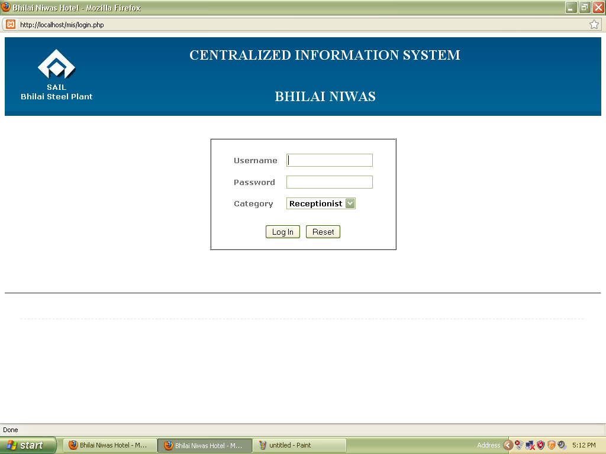

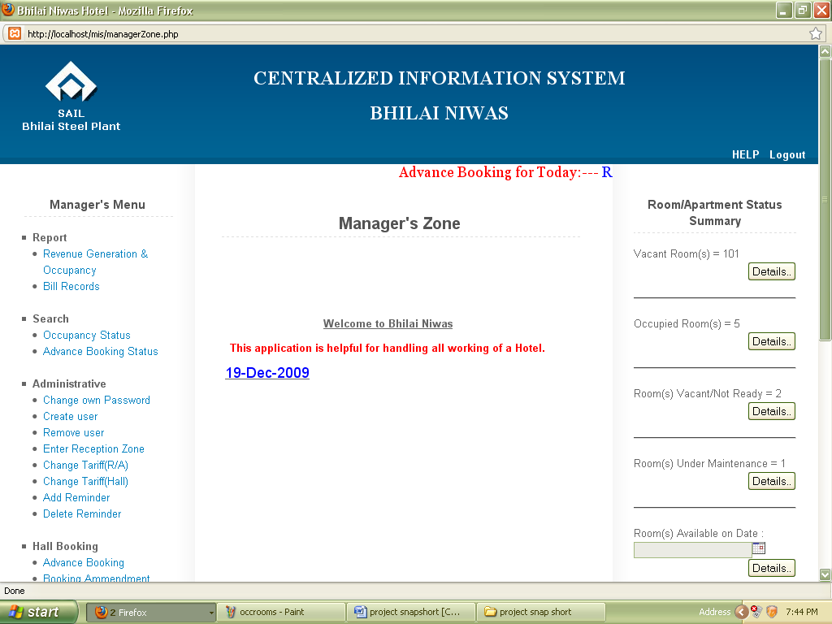
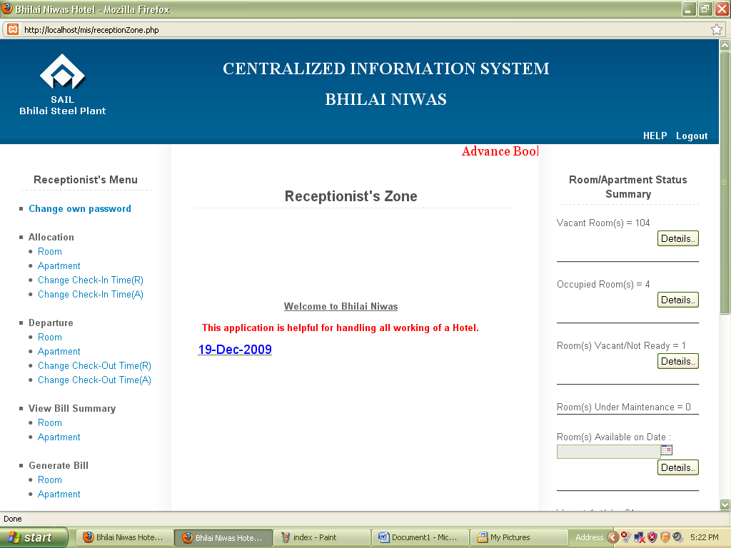
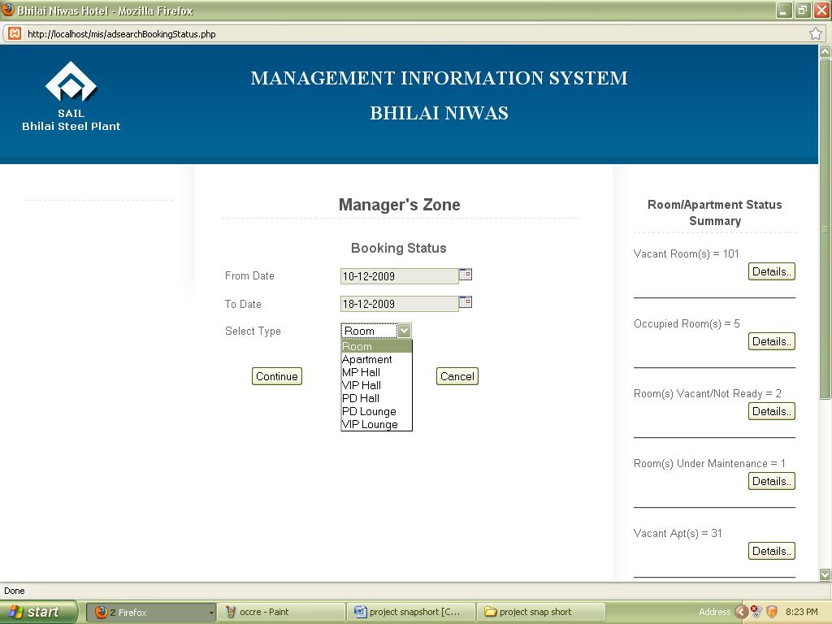

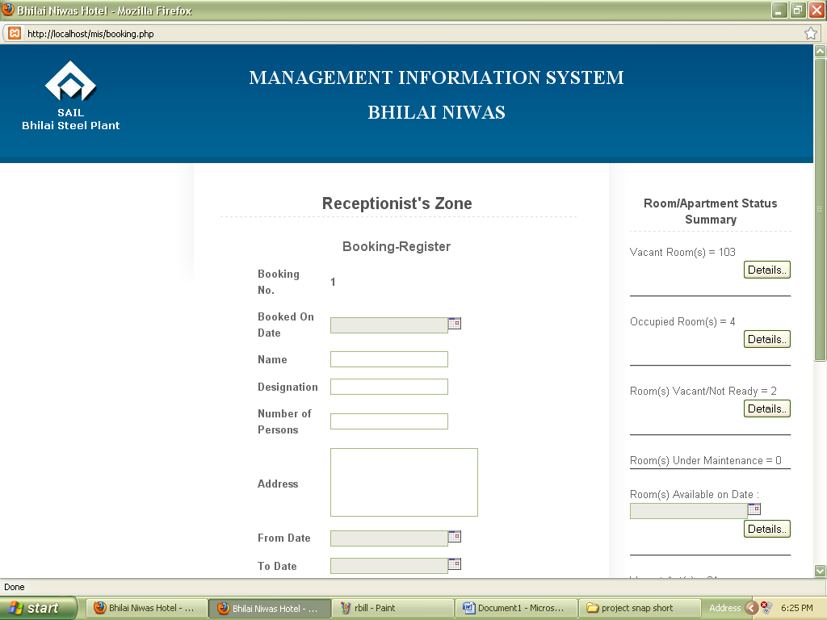

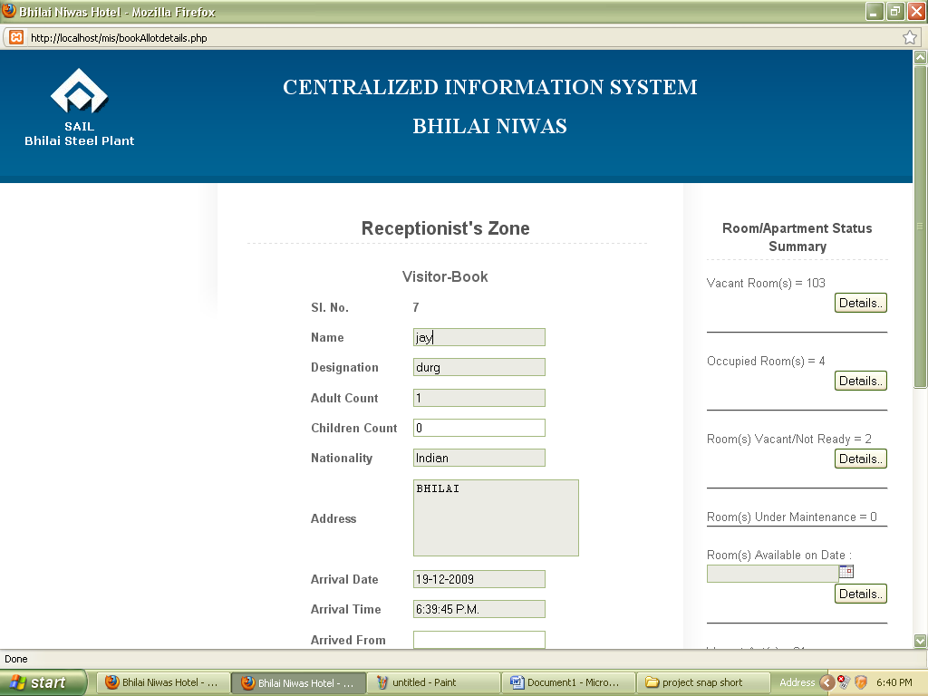

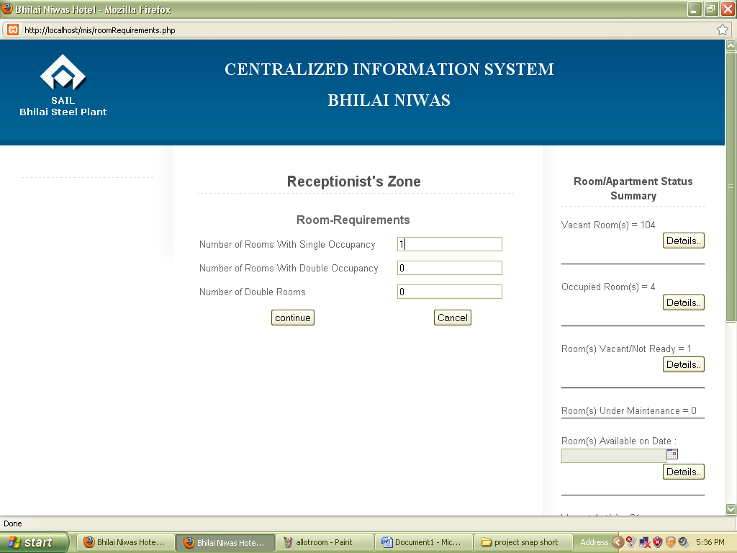

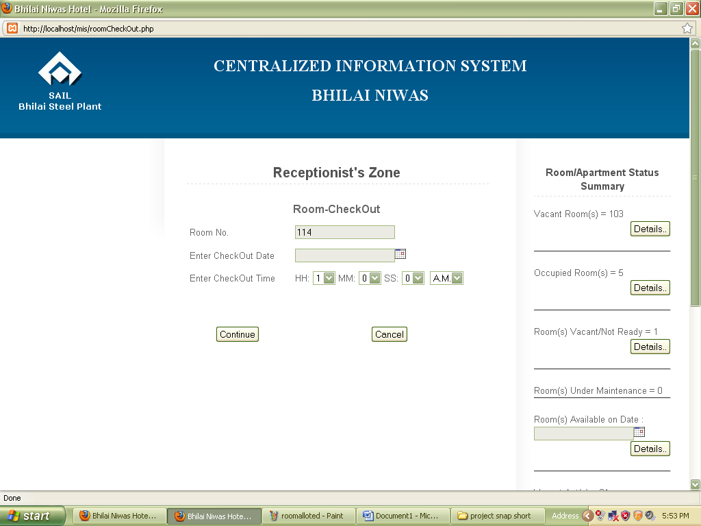

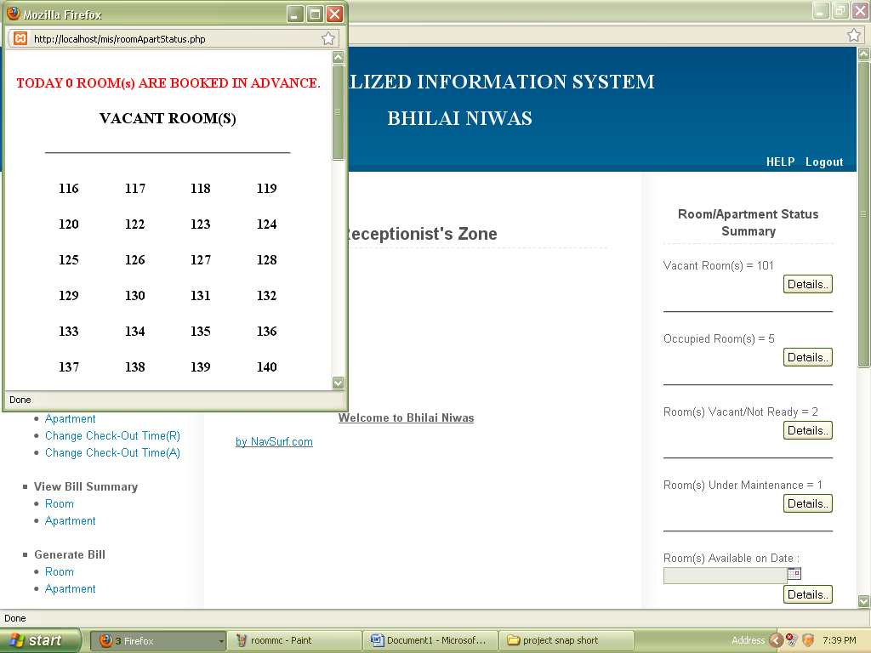

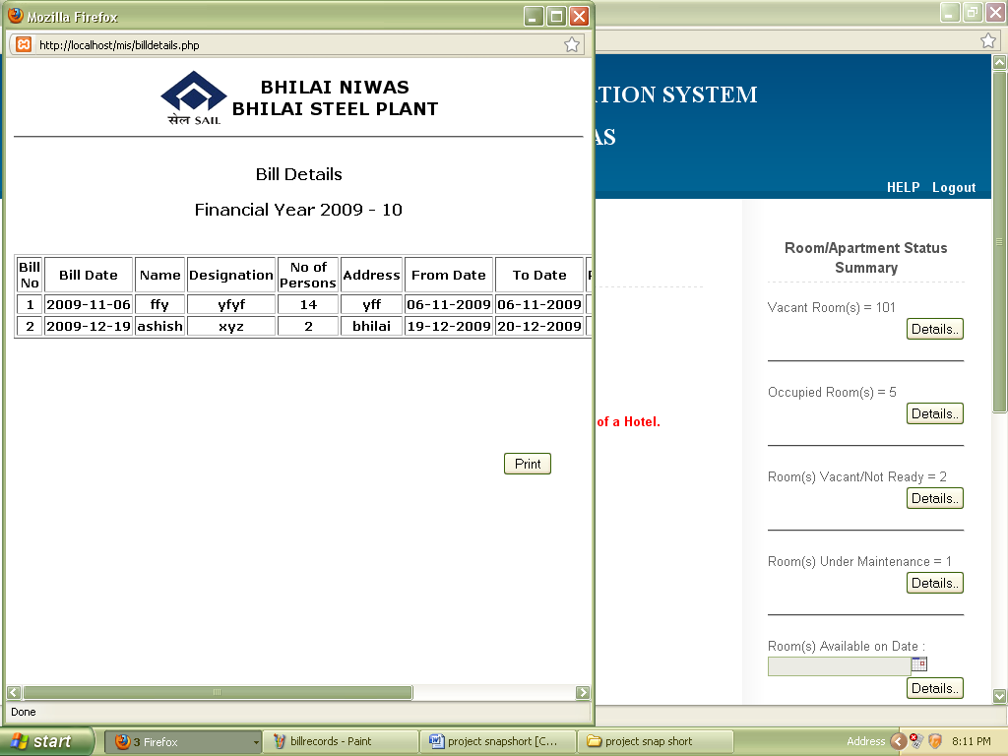

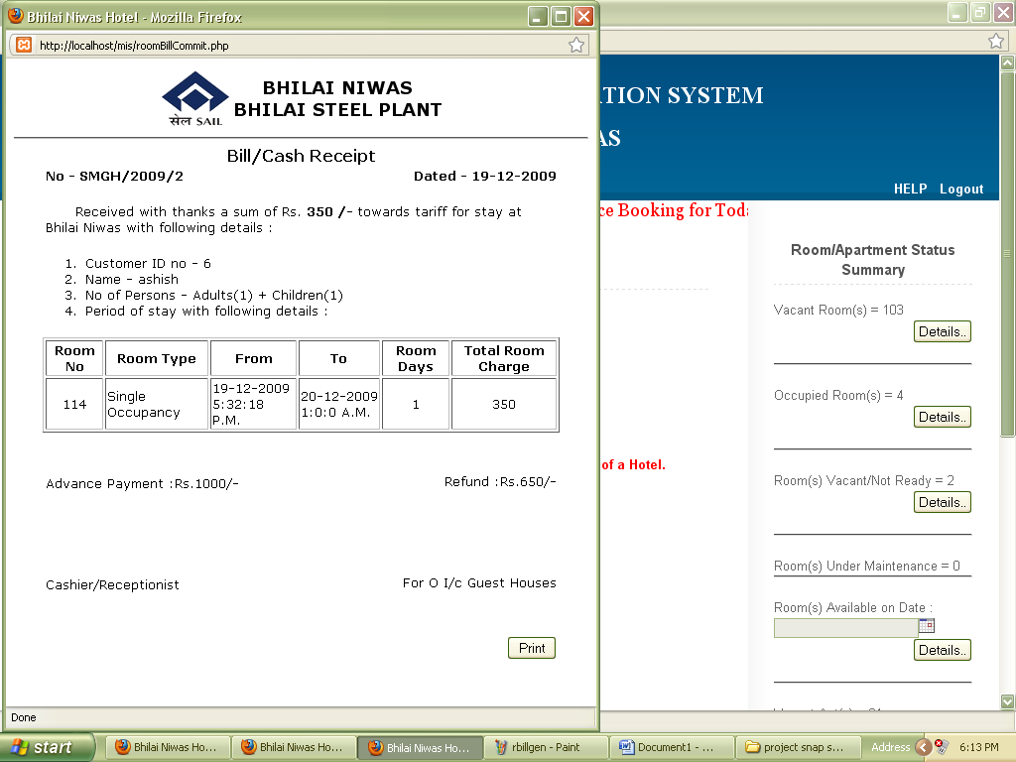

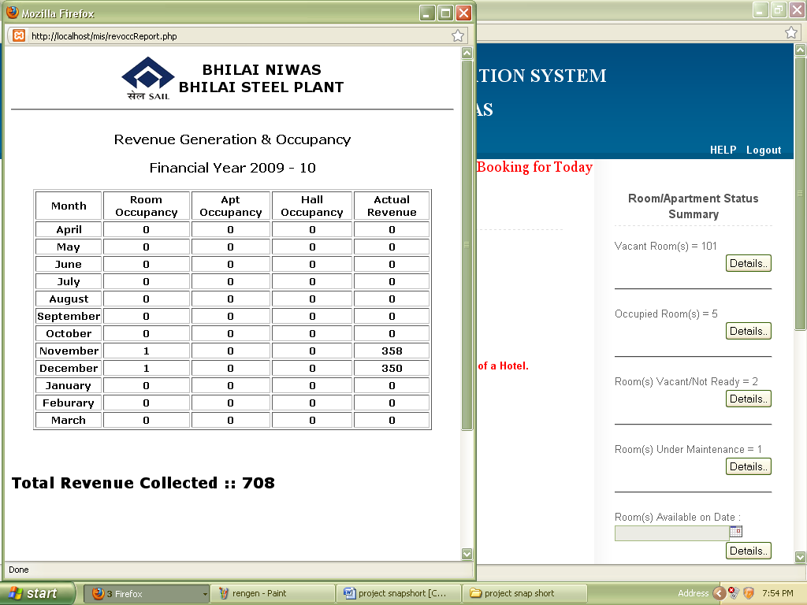

CONCLUSION & SCOPE OF FUTUREWORK

CONCLUSION& SCOPE OF FUTUREWORK

CONCLUSION

Here upon the project has been developed with the intention to automate the workings at BHILAI NIWAS. The concept of developing "CIS" is to reduce the time consumption for transactions and to ensure error-free and legal and secured record keeping.
With the conclusion of our project, we hope that our work will be proved helpful and will help Bhilai Niwas to conduct operations successfully, effectively with an ease.

SCOPE OF FUTURE WORK

- Catering staff and Management interaction system is to be implemented yet.
- Staff automatic attendance system is to be applied.

BIBLIOGRAPHIE

BIBLOGRAPHIES

Essential PHP Security

Learning PHP5

PHP for Dummies

PHP in Nutshell

PHP Power Programming

